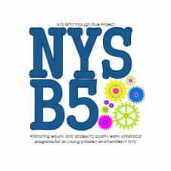
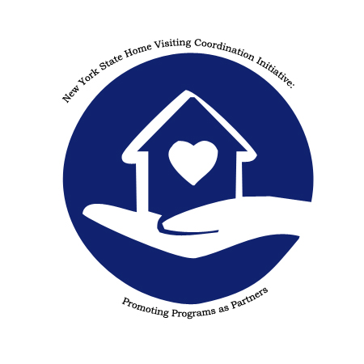

https://www.nyshomevisitcoord.com
Upcoming Webinars

January 28, 2021 10:30 - 12:00 EST
Recognizing and Responding to Domestic Violence for Home Visitors Part I
Presented by Bonnie Allen, Domestic Violence Program Administrator, NYS OPDV

This two-part webinar will provide home visitors with knowledge and skills to identify and respond in a survivor centered, effective and safe manner to domestic violence. The presentation will explore the dynamics of domestic violence and how to engage with both victims and their abusive partners. The impact of domestic violence on children and how to promote safety and healing for children and families will be discussed. The unique challenges of specific populations experiencing domestic violence will also be covered. Content will include safety concerns, planning and assessment and partnering with Domestic Violence Service Providers to support victims and their children. Resources will be provided for further information.

Part 1
- Understanding the Dynamics of Power and Control
- Recognizing and Partnering with the Domestic Violence Victim
- Recognizing and Engaging with Abusive Partners
- The Impact of Exposure to Domestic Violence on Infants and Young Children
- Promoting Safety and Healing for Victims and Children
- Resources
February 4, 2021 10:30 - 12:00 EST
Recognizing and Responding to Domestic Violence for Home Visitors Part I
Presented by Bonnie Allen, Domestic Violence Program Administrator, NYS OPDV

This two-part webinar will provide home visitors with knowledge and skills to identify and respond in a survivor centered, effective and safe manner to domestic violence. The presentation will explore the dynamics of domestic violence and how to engage with both victims and their abusive partners. The impact of domestic violence on children and how to promote safety and healing for children and families will be discussed. The unique challenges of specific populations experiencing domestic violence will also be covered. Content will include safety concerns, planning and assessment and partnering with Domestic Violence Service Providers to support victims and their children. Resources will be provided for further information.

Part 2
- Identifying Domestic Violence
- Safety Considerations in Homes Where There May be DV
- Additional Concerns When DV is Present in Specific Populations
- Collaboration with Domestic Violence Service Providers
- Resources
February 18, 2021 11:00 - 12:00 EST
Immigrant Families and Home Visiting services in New York: Challenges and Opportunities
Presented by Maki Park, Senior Policy Analyst, Migration Policy Institute

In this webinar, a demographic overview of immigrant families with young children in New York, along with implications for their participation in home visiting services, will be provided. Presenters will also highlight promising practices and policies in effectively and equitably serving immigrant and other Limited English Proficient (LEP) families from states and counties across the United States.

March 3, 10:00 - 11:30 EST
Native American Cultural Competency Part I
Presented by Pete Hill, Special Initiatives Coordinator, Native American Community Services
This two-part series will provide an overview of major Native and Haudenosaunee cultural concepts, discuss challenges to Native health and well-being, and share recent and emerging efforts to support family, child & community wellness.
Part I: Cultural Grounding, Diversities of Indigenous Peoples, Screening of “Unseen Tears: The Impact of Native American Residential Boarding Schools in Western New York”

March 10, 10:00 - 11:00 EST
Native American Cultural Competency: Part II
Presented by Pete Hill, Special Initiatives Coordinator, Native American Community Services
This two-part series will provide an overview of major Native and Haudenosaunee cultural concepts, discuss challenges to Native health and well-being, and share recent and emerging efforts to support family, child & community wellness.
Part II: Overcoming Residual Impacts of Historical Traumas, Recommendations & Strategies to Build Greater Connections & Program Effectiveness

April 13, 11:00 - 12:00 EST
Child Abuse and Neglect Prevention for Home Visitors and Early Childhood Professionals
Presented by Timothy Hathaway, Executive Director, Prevent Child Abuse New York**

May 12, 2021 11:00 - 12:00 EST
ASQ Data Tool Usage and Applications
Presented by Melissa Passarelli, Director of Programs, Docs for Tots**

June 16, 2021 11:00 - 12:00
Growing Up Healthy Hotline Overview, NYS Parent Portal
Presented by Lucinda Caruso, Director, Maternal and Infant Health Home Visiting Program Bureau of Women, Infant and Adolescent Health, Department of Health**

In partnership with Moving on Maternal Depression Schuyler Center for Analysis and Advocacy (SCAA) Webinar series.

July 8, 2021 11:00 - 12:00
NYS Children's Alliance Program Awareness
Presented by Jami Bolton, Education and Training Coordinator, and Clare Robinson-Henrie, Director of Statewide Programming, New York State Children’s Alliance Inc.**

August 11, 2021 10:00 - 11:00 EST
National Home Visiting Coalition Update
Presented by Lisa Foehner, Director of Advocacy and Strategic messaging at Parents as Teachers National Center and member of the National Home Visiting Coalition.**

September 15, 2021 11:00 - 12:30 EST
What was I thinking? -- Effective Strategies for Working with Adolescent Parents
Presented by Cicatelli Associates, a diverse, mission-driven nonprofit organization dedicated to improving the quality of healthcare and social services.

October 13, 2021 1:00 - 2:00 EST
Home Visiting and Social Determinants of Health
Presented by Kate Breslin, Presented and CEO of the Schuyler Center for Analysis and Advocacy.

** Session descriptions will be available in webinar communications that contain registration information

This publication is supported by the Preschool Development Grant Birth through
Five Initiative (PDGB5), Grant Number 90TP005901, from the U.S. Department of
Health and Human Services, Administration for Children and Families, Office of Child
Care. Its contents are solely the responsibility of the authors and do not necessarily
represent the official view of the United States Department of Health and Human
Services, Administration for Children and Families.

